**Weekly Daily & SOW**

**Weekly tracker:**

**Process training update: Here we just update what is the training done**

**Clarifications about weekly tracker:**

**Sheet2: Prudential ID creation:** The task of transition manager is that he will have to take the name s& share it with Prudential.When the IDs have been created the client sent us an email as a confirmation. They also send the details like these are the login details can you get them checked. Transition manager asks the operations Lead assistant manager asking him to check. Then there was also a situation that some ID were working, some were not working.When we followed up with the client , they had a missed out on a few IDs. Then they had created IDs for the missing names.Then the operations colleagues who had missed out on login ids also got their respective accesses.

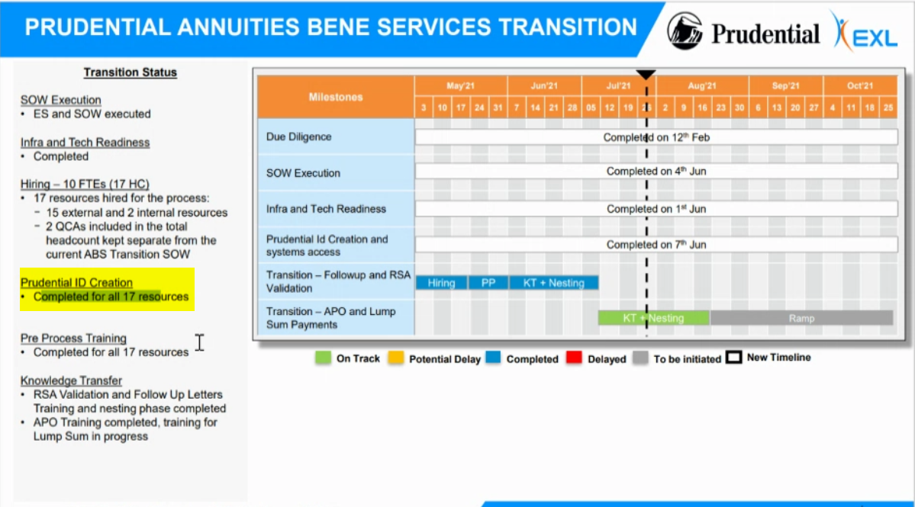

Sheet number 4: Open items, issues & risks:

The below highlighted topics were shared by Operations team to the client. Here the client has informed that they will update by the end of last week.

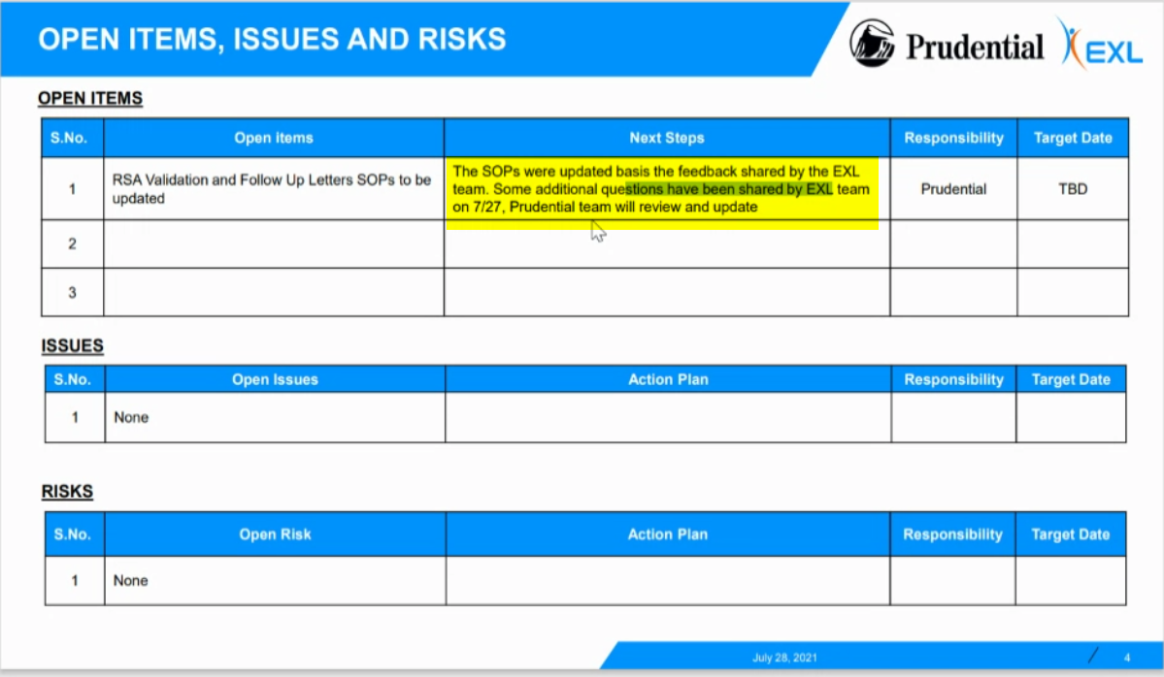

**Sheet no 7: Process training update:**

What does internal team huddle mean: Here it means that everyday the operations team do a huddle.

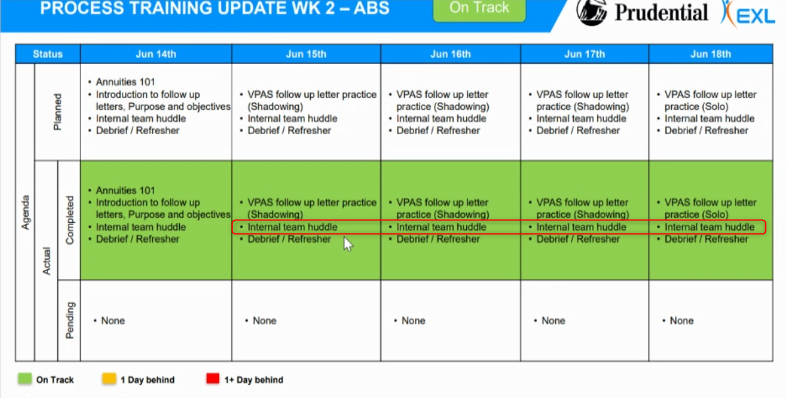

**General topic on weekly tracker: With whom all you got in touch for this weekly tracker?** Transition manager get in touch with Operations AM or LAM. We do not have access to the agenda or Prudential Ids so it is LAM or Operation AM who sends these details or Transition manager collects it from him. Every day Transition manager calls up to LAM at the end of the day to ask him to check if everyone were present, how did it go, are we on track, are there any issues. In the below screen shot the transition manager has updated all the requisite details post discussion with LAM.

Note on usage of client logos: Prudential Logos can be used if the deck is used internally that is with in Prudential team & Exl team, if it is used outside then you will need permission from Prudential. If it is new client & they will only provide logo.

**Call details for 4th August:**

**ABS Transition Tracker/ Daily Tracker:**

Is a tracker that is shared on a daily basis. Every two days once this meeting is held it was initially every day.

KT Schedule & Status: is shared on a daily basis. The contents in this tab is also there in Weekly tracker.

Attendance tracker: is where we capture the attendance for the batch.

Systems logging: is done in the beginning of the batch. This is done to check if accesses are working. Even the systems accesses are tracked on a regular basis. It could be possible that one or two of them can struggle with accesses. Even this is tracked.

KT Assessment: Here in this tab we track the scores on a regular basis.

Risks: If there are any risks those should be listed(Can Suhel give certain examples of Risks)

Issues: Go through issues

BGC & Drug test: is the back ground checks that are to be done. Depending upon the process that you are joining back gorund check items will be shared by recruitment team(Back ground checks)

If there are additional checks to be done this will be clearly defined in Statement of work. If there are five category of checks as defined by Prudential than only those checks to be done.

From whom did Suhail get these details from to update in tracker Suhel said he will share the latest implementation plan

**Clarifications regarding daily tracker:**

**BGC & Drug test**: The drug test status was also part of the agreement with Prudential. The details in BGC status & Drug test status, Transition manager gets it from Operations team.All details Suhel got this from Operations like id creation & other Drug status test.

Ranjan Bannerjee is contact from Operations team for Suhel.

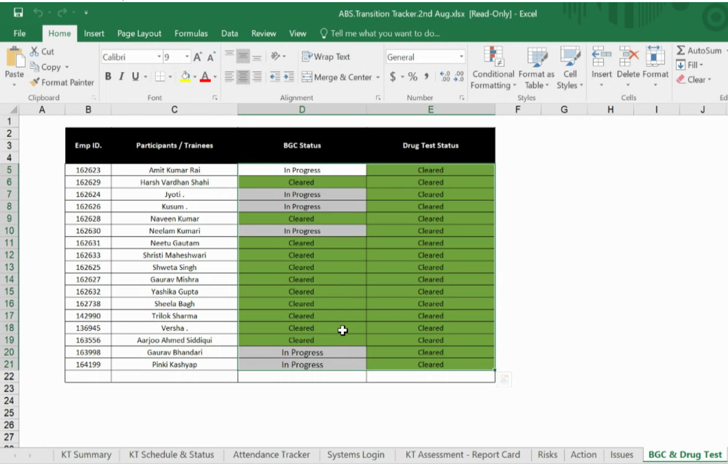

**Latest Implementation Plan for annuity Bene services:** In the SOW the latest implementation plan is there.

**Screen shot of latest implementation plan:**

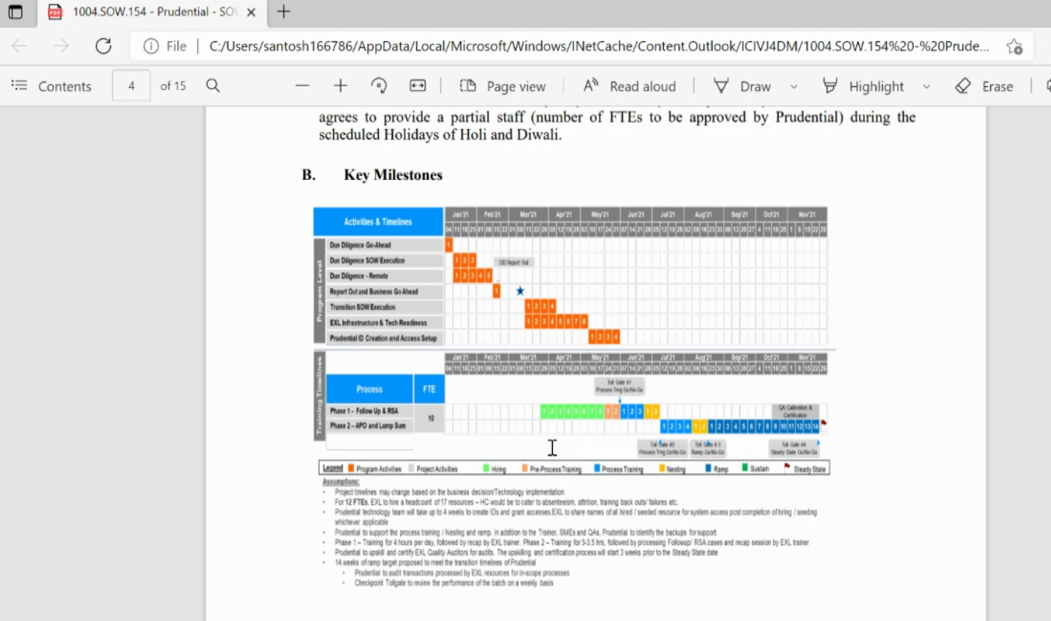

**Statement of work:**

This is document what we need for every transition. If it is existing client then we will have to use it. Jagan might have it.

Details mentioned are :

What are the processes,

How many FTEs,

Working hours(Indian holidays we will have to discuss with client & then take holiday)

Business holidays

Key mile stones

When is Ramp start when is Steady state,

Scope & out of scope

Ramp Plan

List of applications

Bpromt: application is the one that tracks the time of production hours logged in by operations team.

Name of stakeholders(check with Suhail)

Billing amount of transition manager is mentioned USD 1200 Per week

The X denotes it is FTE based as per below screen shot. Prudential is FTE based billing.

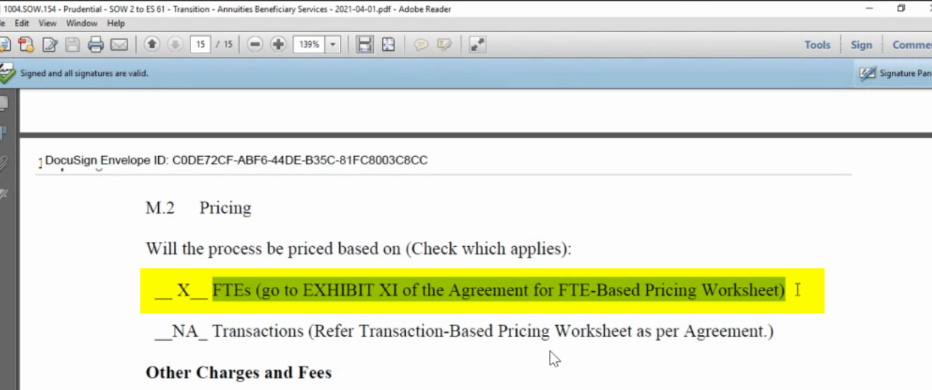

The SOW will figure in Engagement schedule which we don’t have to work on time & time again. We only have to work on Statement of Work

